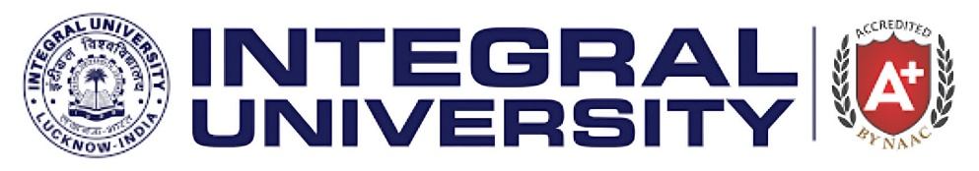
INTEGRAL INSTITUTE OF NURSING SCIENCE& RESEARCH
Title of the Activity: An extension activity on “World Breast Feeding Week” 2025
Name of scheme: Pradhan Mantri Matru Vandana Yojana (PMMVY), a central government initiative supporting pregnant women and lactating mothers.
Session and Date: on 06th August 2025
Place of the Event: OPD Building, Ground floor, BLOCK- G, Integral University.
Event organized by the department: Integral Institute Of Nursing Science& Research
Name of the Collaborating agency: National Social Service (NSS)
Number of the faculty members involved: 06
Number of Participants: 100
Objectives:
• To highlight the health benefits of breastfeeding for infants and mothers.
• To encourage exclusive breastfeeding for the first six months of life.
• To provide correct information and dispel myths about breastfeeding.
• To motivate healthcare workers and community members to support breastfeeding mothers.
World Breastfeeding Week is celebrated every year from 1st to 7th August to promote the importance of breastfeeding for both mother and child. In line with the global initiative by the World Alliance for Breastfeeding Action (WABA). The Theme for this year was "Prioritise Breastfeeding: Create Sustainable Support Systems". So with this approach, students of B.Sc and GNM 2nd yr, IINSR organized a Roll play on 06th August 2025 to raise awareness, educate, and support breastfeeding practices among mothers, families, and the community.

GLIMPSE OF THE DAY:
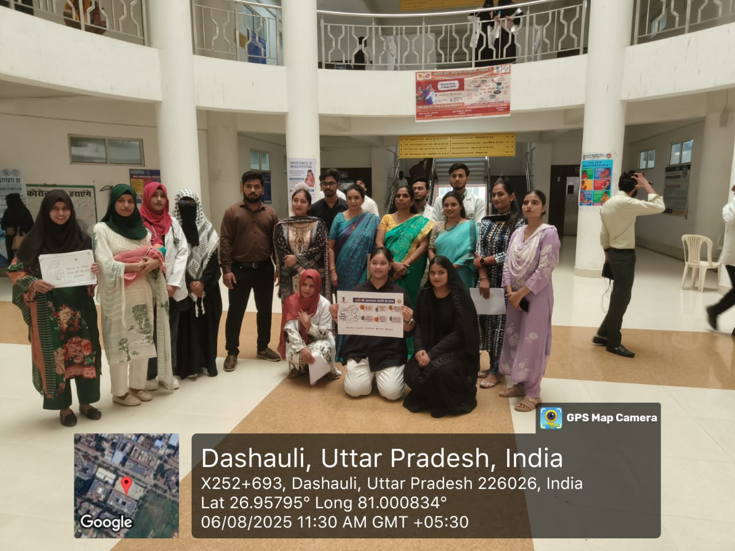
- Photograph with HODs and Students

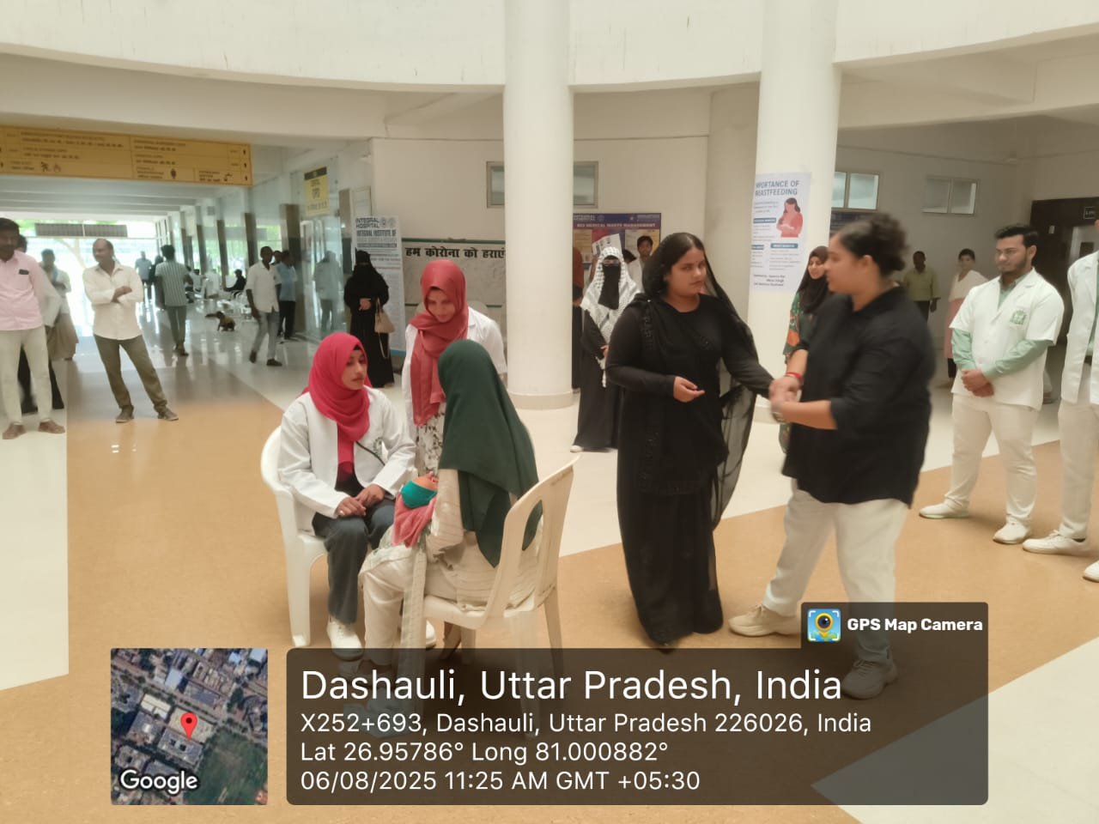
- Photograph of Students performing RollPlay

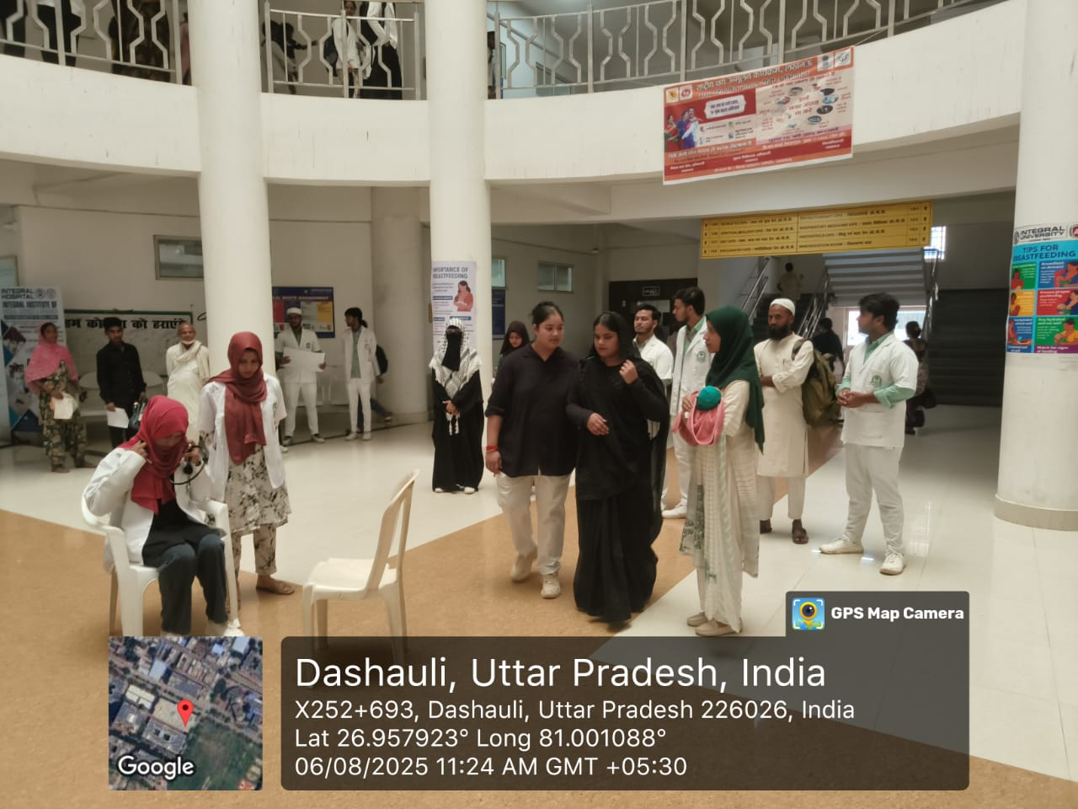
- Photograph of Students performing RollPlay

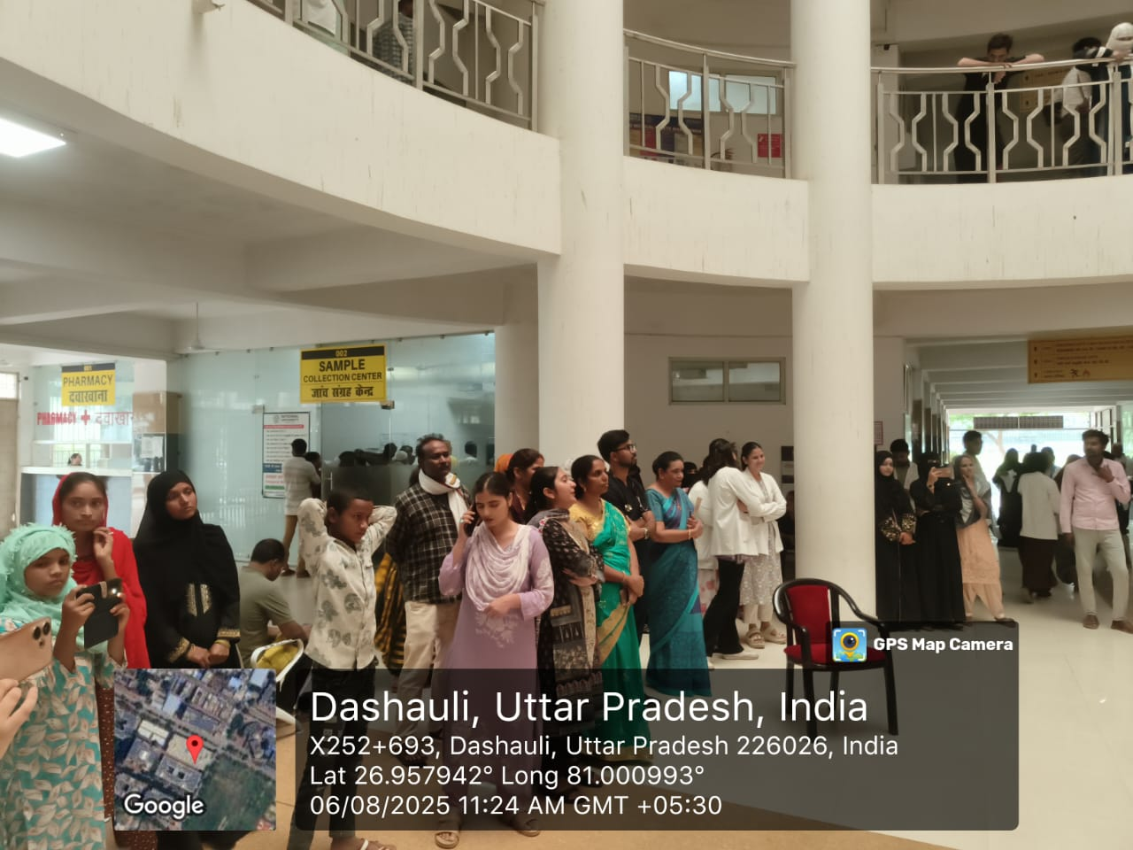
- Photograph showing Public Participation.

